**How to install plugin?**

== Installation === Requires WooCommerce =1. Upload the plugin files to the '/wp-content/plugins/automate-dropshippingb2b' directory, or install the plugin through the WordPress plugins screen directly.2. Activate the plugin through the 'Plugins' screen in WordPressGo to `Plugins > Add New > Upload Plugin` (Upload a zip file of plugin).

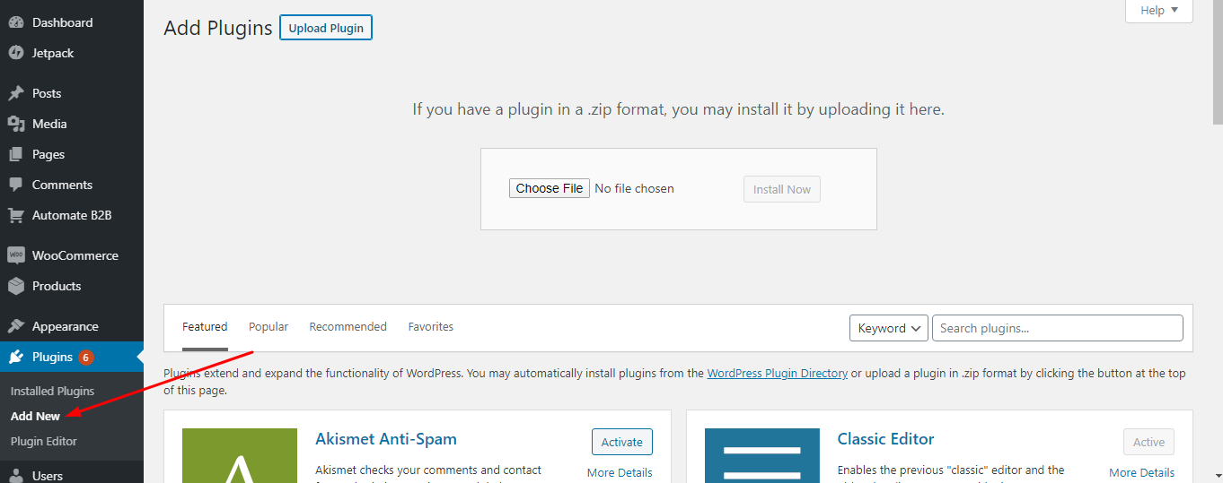

**How to setup or use plugin?**

**Step 1-** Go to "http://klockjatten.midriffdevelopers.live/wp-admin" and login with below credentials.

Username - admin

Password - Livefor2020@#

**Step 2-** Go to settings page from `Admin menu > Automate B2B > Settings` and fill the required fileds.

See the image for more details -   
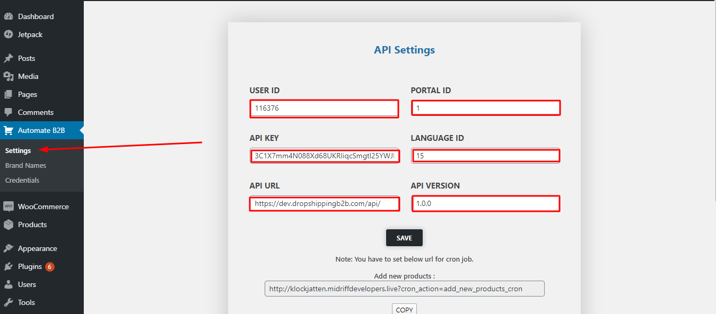

**Step 3-** Go to `Automate B2B > Brand Names` and assign your brand name to category. 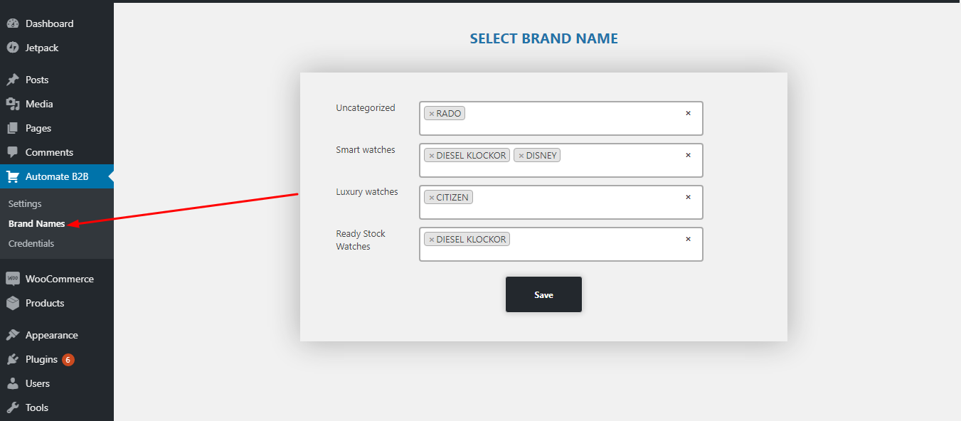  
 **Note - If you don't have category please make sure create category first.**

To create a category Go to `Products > Categories` and create new category.

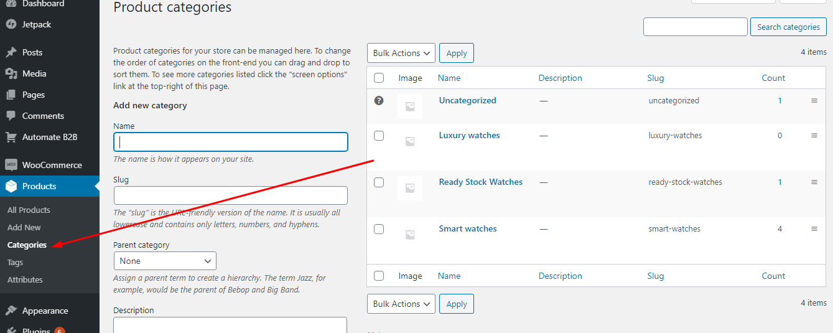.

**Step 4 -** Go to `Automate B2B > Credentials` download the sample file then edit file with your payment credentials then upload it.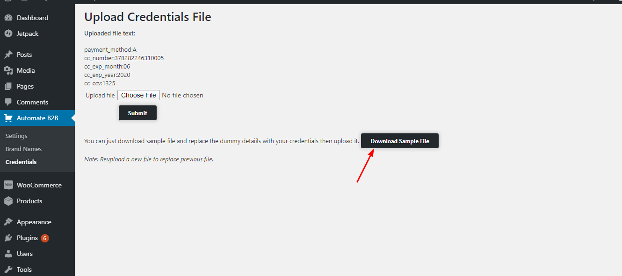

**== Frequently Asked Questions ==**

**= How to import products? =**

Go to settings page from `Admin menu > Automate B2B > Settings` copy add new product url and setup it with cron job for automate import product or manually hit the url.

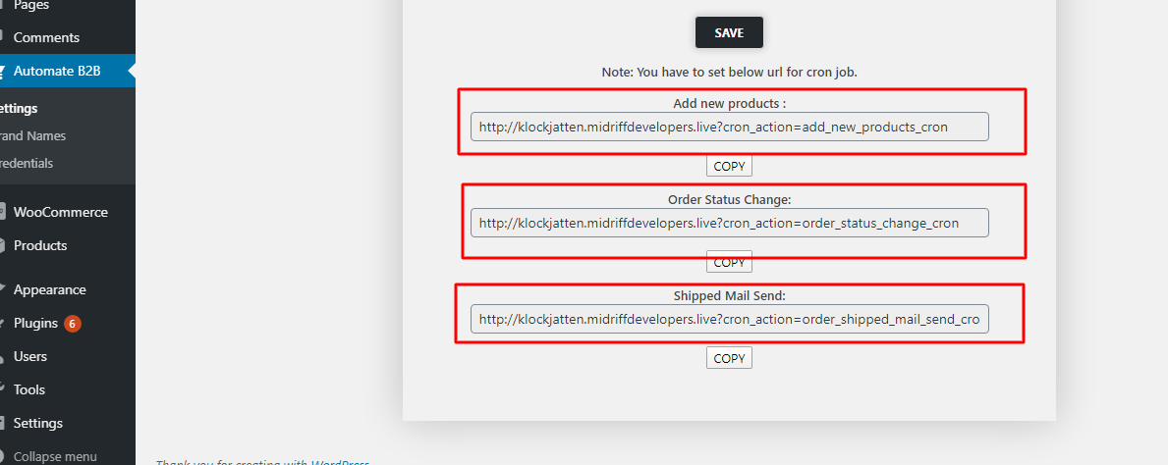

*(****if you hit url manually it can be take long time depending on number of products so be patient.)***

**= How to change order status new to ready? =**

Copy the "Order Status Change" url follow previous step for url and setup it with cronjob or hit manually.

**= How to send shipped mail? =**

Copy the “Shipped mail send” url and setup it with cronjob. When order is shipped it will automatically send shipped mail to user with Shipping company and tracking number details.